South Sudan NGO Forum Standard Operating Procedures (SOP) for members

This SOP provides generic guidance on measures to adopt to minimise the risk of infection and transmission and the non-medical management of Covid-19. Patients that need medical support must be referred to medical practitioners.
- What is a virus?
A virus consists of a piece of genetic material (RNA or DNA) inside a capsule of fats and protein. It is not a living organism and it is much smaller than a bacterium. In order to reproduce, it must invade a cell and take over the cell’s reproductive mechanisms to multiply. It then causes the cell to burst releasing thousands of copies of itself to invade other cells.
- How does COVID-19 spread?
People can catch COVID-19 from others who have the virus and by touching surfaces on which there are viable virus particles. The disease can spread from person to person through small droplets from the nose or mouth which are spread when a person with COVID-19 coughs or exhales and then inhaled by someone nearby. The droplets also land on objects and surfaces around the person where the virus can remain viable for hours or days. People who touch these contaminated surfaces can contract Covid-19 by transfer the virus particle by touching their eyes, nose or mouth. Social distancing reduces the risk of inhaling virus particles, strict hand hygiene reduces the risk of transferring virus particle to the eyes, nose or mouth.
- Case definitions
Case definitions are revised as new information accumulates but the following provides guidance on when someone probably has Covid-19:
- A patient with acute respiratory illness (fever and at least one sign/symptom of respiratory disease, e.g., cough, shortness of breath), AND a history of travel to or residence in a location reporting community transmission of COVID-19 disease during the 14 days prior to symptom onset;
OR
- A patient with any acute respiratory illness AND having been in contact with a confirmed or probable Covid-19 case in the last 14 days prior to symptom onset;
OR
- A patient with severe acute respiratory illness (fever and at least one sign/symptom of respiratory disease, e.g., cough, shortness of breath; AND requiring hospitalization) AND in the absence of an alternative diagnosis that fully explains the clinical presentation.
A fever is defined as a body temperature above 37.8C.
Mild symptoms are considered to be: Cough and sore throat, Low grade fever below 38°C, 12-20 breathes per minute, Heart rate below 100 beats per minutes
Moderate symptom are considered to be : Cough, sore throat, fever above 38°C, muscle pain, shortness of breath, 20-30 breaths per minute, heart rate 100-120 per minute
If the symptoms deteriorate, admission to a medical facility should be considered.
- Contact and self-quarantine
Quarantine refers to someone who has been potentially exposed to Covid-19 and separates themselves from others to avoid infecting other people.
Isolation refers to some who is experiencing the symptoms of Covid-19 and separates themselves from others to avoid infecting other people.
A person is considered a contact if they have been with a probable or confirmed Covid-19 case during the 2 days before and the 14 days after the onset of patient’s symptoms and experienced:
- Face-to-face contact with a probable or confirmed case within 1 meter and for more than 15 minutes;
- Direct physical contact with a probable or confirmed case;
- Direct care for a patient with probable or confirmed COVID-19 disease without using proper personal protective equipment
If these conditions apply the person who has been in contact must self-quarantine for 14 days.
If someone is infected by Covid-19, they will show symptoms within 14 days. In the absence of tests, self-isolation for 14 days is the best way of a person demonstrating that they do not have Covid-19 virus.
Staff should self-quarantine for 14 days if the staff member
- Has returned from countries in which there has been community transmission (now most countries in the world)
- Has been in close contact with someone who had (or developed afterwards) the symptoms of Covid-19
- Has had face-to-face contact with a probable or confirmed case within 1 meter and for more than 15 minutes;
- Has a fever of above 37.8C
- Has a persistent cough.
- Has other symptoms of Covid-19.
- Has been diagnosed with Covid-19 or if the symptoms are beyond reasonable doubt even if tests are not available.
- Has had direct care for a patient with probable or confirmed COVID-19 disease without using proper personal protective equipment (PPE)
- Who is at risk of developing severe illness?
The world is still learning about how COVID-19 affects people. Anybody can catch Covid-19 but most people do not get sick. Older people (over 65) and people with pre-existing medical conditions (such as malnutrition, high blood pressure, sickle cell anaemia, heart disease, diabetes, chronic kidney disease, chronic liver disease) appear to develop serious illness more often than others. Contracting other diseases such as malaria may increase the risk of severe illness.
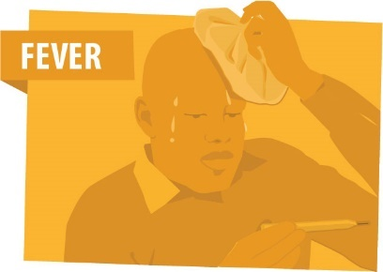 | 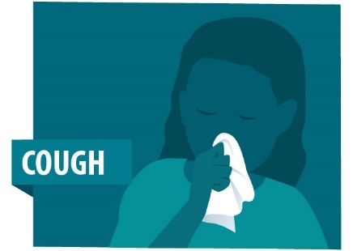 | 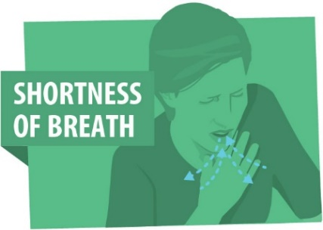
The most common symptoms of COVID-19 are fever, tiredness, and dry cough. Some patients may have aches and pains, nasal congestion, runny nose, sore throat or diarrhoea. These symptoms are usually mild and begin gradually. Some people become infected but don’t develop any symptoms and do not feel unwell. Most people (about 80%) recover from the disease without needing special treatment. Around 1 out of every 6 people who gets COVID-19 becomes seriously ill and develops difficulty breathing. Globally, about 2% of people known to be infected with the disease have died but some countries have recorded more than 10% of known cases dying as a direct or indirect consequence of the virus.
Currently there is no evidence that pregnancy increases the risk of severe illness or that pregnant women present with different sign and symptoms. There is no evidence of mother-to-child transmission during pregnancy, birth and breastfeeding).
- Infection Prevention and Control (IPC)
There is currently no vaccine for Covid-19.
The best way of responding to the threat of Covid-19 is by preventing its spread. The virus is physically disrupted by soaps and detergents which break up the protein/fat outer layer of the virus. High concentrations of alcohol (>60%) and water with 0.5% sodium hypochlorite (20ml of sodium hypochlorite per litre of water, which must be regularly changed) are also effective. The virus seems to be quite heat stable and requires temperatures in excess of 60°C for 15 minutes (for reference, water above 45°C is too hot to keep you hand in).
To reduce the risk of transmission, good hand hygiene, (washing with soap and water for 20 seconds), social distancing of 2 metres and no touching (no handshakes, hugging, kissing) should be implemented in the work place and guest houses. Use of alcohol based sanitisers should be used only when soap and water are not available. National staff should be advised to introduce the same measures in their personal lives in their homes. Except for health care workers caring for patients, washing hands should be encouraged over wearing gloves which provides no protection against the virus.
Common touch areas (e.g. door handles, kitchen utensils) should be regularly cleaned with a detergent mixture.
Some people can be infected and show either very mild symptoms or no symptoms but still be infectious. People who fall ill may be infectious for 2 days before showing any symptoms.
Anyone with a cough or cold, whether or not it is Covid-19 must:
- Cover the nose and mouth with when coughing or sneezing.
- Dispose of any used tissue in a trash bin and then wash their hands. The bins should be covered and the contents burned.
All staff should be encouraged to wear a cloth face mask than covers the mouth and nose when in the presence of other people closer than 2 metres: a cloth face mask reduces the risk that someone can infect someone else by breathing out virus particles and reduces the risk of infection by breathing in virus particles
- Management of sick staff: no personal carer
If a staff member presents symptoms, they are to immediately remove themselves from the vicinity of other people and report to the Line Manager or another manager. Staff at home or in the guesthouse must not to come to the office but report in sick and self-isolate. If medical opinion finds that the symptoms meet the case definition, the staff member must self-isolate for 14 days in a room or location where they can avoid contact with anyone else and have exclusive use of a bathroom. Someone must be appointed to provide food and water to the person in isolation.
A carer should deliver food and water and any other supplies to the door of the patient’s room and then retreat at least 2 metres before the patient retrieves the items. If the patient has items to dispose of, the carer can place a waste bin with a liner next to the door. The patient can deposit the waste into the lined bin and after the patient has retreated, the carer can seal the liner and remove it for disposal
Anyone who develops a fever must self-isolate and continue to self-isolate for 72 hours after the fever has gone without the use of fever-reducing medicines such as paracetamol. This will help ensure that the fever is truly gone and the person is no longer infectious.
Avoid sharing items from the patient’s immediate environment such as, cigarettes, eating utensils, dishes, drinks, towels, washcloths or bed linen.
To contain respiratory secretions, a medical mask should be provided to the patient and worn as much as possible. Individuals who cannot tolerate a medical mask should use rigorous respiratory hygiene − that is, the mouth and nose should be covered with a disposable paper tissue when coughing or sneezing. Materials used to cover the mouth and nose should be discarded or cleaned appropriately after use (e.g., wash handkerchiefs using regular soap or detergent and water).
Use dedicated linen and eating utensils for the patient; these items should be cleaned with soap and water after use and re-used.
If well enough and able, the patient should manage the hygiene of their environment including hygiene of the bathroom themselves to avoid infecting a cleaner or carer.
- Management of sick staff: with personal carer
If the patient is not able to look after themselves and requires a personal carer, the carer should:
- wear a tightly fitted medical mask (ideally N95) that covers their mouth and nose when in the same room as the patient and glasses or goggles. Masks should not be touched or handled during use. If the mask gets wet or dirty from secretions, it must be replaced immediately with a new clean, dry mask. Remove the mask using the appropriate technique – that is, do not touch the front, but instead untie it. Discard the mask immediately after use and perform hand hygiene.
- clean and disinfect bathroom and toilet surfaces at least once daily. Regular household soap or detergent should be used first for cleaning, and then, after rinsing, regular household disinfectant containing 0.5% sodium hypochlorite should be applied.
- place contaminated linen into a laundry bag and avoid contaminated materials coming into contact with skin and clothes
- clean the patient’s clothes, bed linen, and bath and hand towels using regular laundry soap and water or machine wash at 60–90°C with common household detergent, and dry thoroughly, if hot water is not available then use TCP or Dettol with the washing powder..
- Wear gloves and protective clothing (e.g., plastic aprons) when cleaning surfaces or handling clothing or linen soiled with body fluids. Depending on the context, either utility or single-use gloves can be used. After use, utility gloves should be cleaned with soap and water and decontaminated with 0.5% sodium hypochlorite solution. Single-use gloves (e.g., nitrile or latex) should be discarded after each use. Perform hand hygiene before and after removing gloves.
- Placed gloves, masks and other waste generated during care into a waste bin with a lid in the patient’s room before being disposed of as infectious waste. Burning the waste is recommended.
Patients should be encouraged to drink at least two litres of water per day or more if there is fever.
- Medical management of severe cases
Some people with symptoms will develop a serious illness. This may be problems breathing or in some cases, blood clots and organ failure. South Sudan has very limited capacity to provide the intensive medical care that such cases require but a limited number of beds have been made available at the John Garang Centre for Infectious Diseases in Juba and may be available in hospitals in State Capitals. For such cases, calling 66-66 will initiate the admission process. Breathing can be assisted by providing oxygen via a face mask assuming that oxygen or oxygen concentrators are available. A medical ventilator requires partial paralysis of the patient and so requires specialist equipment and specialist staff which are in short supply in South Sudan.

For severe cases of Covid-19, call 66-66

- Medical Evacuation
Medical evacuation requires clearance by medical authorities and National Security in South Sudan to travel, acceptance of the air operator to carry a patient and clearance to arrive by the medical and immigration authorities in the receiving country. The approvals of the host country are best achieved through the staff member’s embassy (if there is one) in the country of arrival and typically takes 6-8 days so evacuation must be organised before the patient’s health become critical.
Although the UN has created some capacity for receiving acute cases in Addis Ababa, medical evacuation cannot be assumed as available to neither national nor international staff.
- End of Isolation
Staff may leave isolation when:
- 72 hours after the fever has gone (below 38°C) without the use of fever-reducing medicines such as paracetamol
- Other symptoms have gone or significantly improved
- 7 days have passed since the first on-set of symptoms
If testing is available, two negative tests at 24 hour intervals is sufficient to leave isolation.
It is not yet clear whether recovery from Covid-19 infers immunity or for how long so recovered staff should continue to take normal infection prevention and control precautions.
- Mental Health in Isolation and quarantine
In addition to physical health, the mental health of the isolated or quarantined person, whether sick or well, should be considered. Staff should avoid watching, reading or listening to news that causes anxiety or stress. Staff should seek or be provided with information that gives practical steps to protect themselves, the family and friends.
The Line Manager or the carer or friends should regularly check on the isolated or quarantined person’s well-being to they do not feel forgotten or neglected. Isolated or quarantined staff should try to stay connected via e-mail, social media, video conference and telephone, maintain their social networks and maintain personal daily routines.
Staff should pay attention to their own needs and feelings and engage in healthy activities that are enjoyable and relaxing. Regular exercise, regular sleep routines and eating healthy food all help. To limit anxiety and stress, isolated staff should seek information updates and practical guidance only at specific times during the day from health professionals and recommended websites such as WHO.
Isolated and quarantined should avoid smoking, excessive consumption of alcohol and consumption of other psychoactive substances.
Self – Monitor | Self – Isolate | Quarantine – Suspected | Quarantine – Probable | Quarantine – Confirmed
Monitor for symptoms for 14 days after exposure;  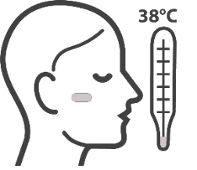  Fever  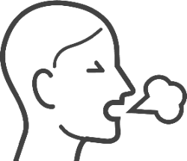  Cough  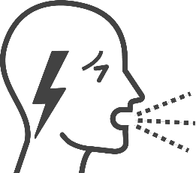  Difficulty breathing | Returning from countries in which there has been an outbreak, OR  As determined by local authorities.  OR  - Face-to-face contact with a probable or confirmed case within 1 meter and for more than 15 minutes;  - Direct physical contact with a probable or confirmed case;  - Direct care for a patient with probable or confirmed COVID-19 disease without using proper personal protective equipment; | Suspect case  - A patient with acute respiratory illness (fever and at least one sign/symptom of respiratory disease, e.g., cough, shortness of breath), AND a history of travel to or residence in a location reporting community transmission of COVID-19 disease during the 14 days prior to symptom onset;  OR  - A patient with any acute respiratory illness AND having been in contact with a confirmed or probable COVID-19 case in the last 14 days prior to symptom onset;  OR  - A patient with severe acute respiratory illness (fever and at least one sign/symptom of respiratory disease, e.g., cough, shortness of breath; AND requiring hospitalization) AND in the absence of an alternative diagnosis that fully explains the clinical presentation. | Probable case  - A suspect case for whom testing for the COVID-19 virus is inconclusive.  OR  - A suspect case for whom testing could not be performed for any reason. | Confirmed case  A person with laboratory confirmation of COVID-19 infection, irrespective of clinical signs and symptoms.

